Overview of C
Structure Of C Program
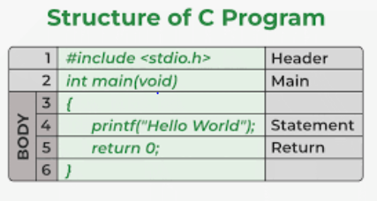

There are 6 basic sections responsible for the proper execution of a program. Sections are mentioned below:
- Documentation
- Pre-processor Section
- Definition
- Global Declaration
- Main () Function
- Sub Programs
Steps involved in the Compilation and execution of a C program:
- Program Creation
- Compilation of the program
- Execution of the program
- The output of the program

- Tokens in C
A token in C can be defined as the smallest individual element of the C programming language that is meaningful to the compiler. It is the basic component of a C program.

Types of Tokens in C
The tokens of C language can be classified into six types based on the functions they are used to perform. The types of C tokens are:
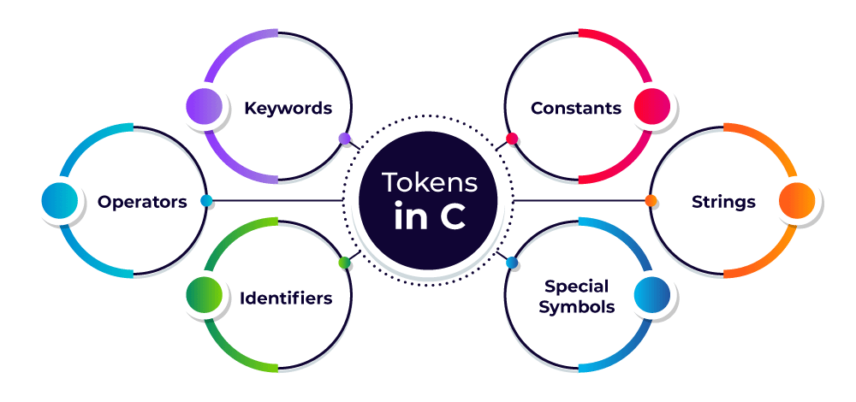

- C Keywords
Keywords are predefined, reserved words used in programming that have special meanings to the compiler. Keywords are part of the syntax and they cannot be used as an identifier. For example:
int money;
Here, int is a keyword that indicates money is a variable of type int (integer).
- As C is a case sensitive language, all keywords must be written in lowercase. C language supports 32 keywords
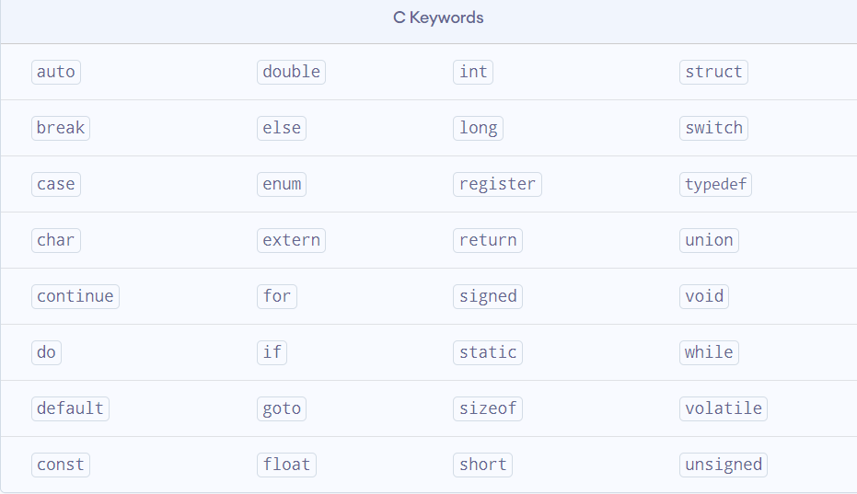

C Identifiers
Identifier refers to name given to entities such as variables, functions, structures etc.
Identifiers must be unique. They are created to give a unique name to an entity to identify it during the execution of the program. For example:
int money;
double accountBalance;
Here, money and accountBalance are identifiers.
Also remember, identifier names must be different from keywords. You cannot use int as an identifier because int is a keyword.

Rules for naming identifiers
- A valid identifier can have letters (both uppercase and lowercase letters), digits and underscores.
- The first letter of an identifier should be either a letter or an underscore.
- You cannot use keywords like int, while etc. as identifiers.
- There is no rule on how long an identifier can be. However, you may run into problems in some compilers if the identifier is longer than 31 characters.
- Constants
The constants refer to the variables with fixed values. They are like normal variables but with the difference that their values can not be modified in the program once they are defined.
Constants may belong to any of the data types.
Examples of Constants in C
const int c_var = 20;
const int* const ptr = &c_var;

- Strings
Strings are nothing but an array of characters ended with a null character (‘\0’). This null character indicates the end of the string. Strings are always enclosed in double quotes. Whereas, a character is enclosed in single quotes in C and C++.
Examples of String
char string[20] = {‘w’, ’e’, ‘l’, ‘c’, ‘o’, ‘m’, ‘e’, ‘\0’};
char string[20] = “welcome”;
char string [] = “welcome”;

- Special Symbols
The following special symbols are used in C having some special meaning and thus, cannot be used for some other purpose. Some of these are listed below:
- Brackets []: Opening and closing brackets are used as array element references. These indicate single and multidimensional subscripts.
- Parentheses (): These special symbols are used to indicate function calls and function parameters.
- Braces {}: These opening and ending curly braces mark the start and end of a block of code containing more than one executable statement.
- Comma (,): It is used to separate more than one statement like for separating parameters in function calls.
- Colon (:): It is an operator that essentially invokes something called an initialization list.
- Semicolon (;): It is known as a statement terminator. It indicates the end of one logical entity. That’s why each individual statement must be ended with a semicolon.
- Asterisk (*): It is used to create a pointer variable and for the multiplication of variables.
- Assignment operator (=): It is used to assign values and for logical operation validation.
- Pre-processor (#): The pre-processor is a macro processor that is used automatically by the compiler to transform your program before actual compilation.

- Operators
Operators are symbols that trigger an action when applied to C variables and other objects. The data items on which operators act are called operands.
Depending on the number of operands that an operator can act upon, operators can be classified as follows:
- Unary Operators: Those operators that require only a single operand to act upon are known as unary operators. For Example increment and decrement operators.

- Binary Operators: Those operators that require two operands to act upon are called binary operators. Binary operators can further are classified into:
- Arithmetic operators
- Relational Operators
- Logical Operators
- Assignment Operators
- Bitwise Operator

- Ternary Operator: The operator that requires three operands to act upon is called the ternary operator. Conditional Operator(?) is also called the ternary operator.

- C Data Types
Data types are the type of data stored in a C program. Data types are used while defining a variable or functions in C. The compiler needs to understand the type of predefined data it will encounter in the program. A data type is an attribute that tells a computer how to interpret the value.
If variables are containers, then the data type is the type of container. The type of container tells what kind of stuff it should contain.

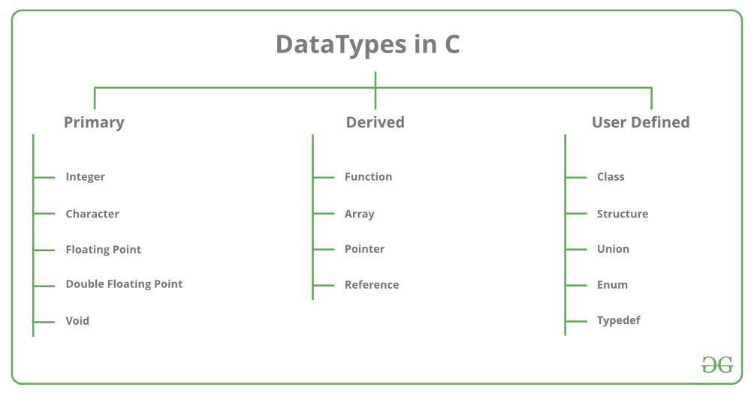

Primitive Data Types | Primitive data types are the most basic data types that are used for representing simple values such as integers, float, characters, etc.
User Defined Data Types | The user-defined data types are defined by the user himself.
Derived Types | The data types that are derived from the primitive or built-in datatypes are referred to as Derived Data Types.

- Primary Data Types In C
The C programming language has primitive or primary data types.
1. Integer (int): Refers to positive and negative whole numbers (without decimal), such as 10, 12, 65, 3400, etc.
Example:
#include <stdio.h>
void main ()
{
int i = 5;
printf("The integer value is: %d \n", i);
}
2. Character (char): Refers to all the ASCII character sets within single quotes such as ‘a’, ‘A’, etc.
Example:
#include <stdio.h>
void main()
{
char c = 'b';
printf("The character value is: %c \n", c);
}

3. Floating-point (float): Refers to all the real number values or decimal points, such as 3.14, 10.09, 5.34, etc.
Example:
#include <stdio.h>
void main()
{
float f = 7.2357;
printf("The float value is: %f \n", f);
}

4. Double (double): Used when the range exceeds the numeric values that do not come under either floating-point or integer data type.
Example:
#include <stdio.h>
void main()
{
double d = 71.2357455;
printf("The double value is: %lf \n", d);
}

5. Void: Void is an empty data type that has no value. We use void data type in functions when we don’t want to return any value to the calling function.
Example:
void sum (int a, int b); – This function won’t return any value to the calling function.
int sum (int a, int b); – This function will return value to the calling function.

- Modifiers in C:
Modifiers are keywords in c which changes the meaning of basic data type in c. It specifies the amount of memory space to be allocated for a variable. Modifiers are prefixed with basic data types to modify the memory allocated for a variable. There are four data type modifiers in C Programming Language:
• signed
• unsigned
• short
• long
•signed - It is default modifier of int and char data type if no modifier is specified. It says that user can store negative or positive values.
•unsigned - It is used on int and char data type. It says that user can store only positive values.
•short - It limits user to store small int values and occupies 2 bytes of memory space in every operating system. It can be used only on integer data type.
•long - This can be used to increased size of the int or double data types to 2 more bytes.
- Storage class modifiers
A storage class defines the scope (visibility) and lifetime of variables and/or functions within a C Program. They precede the type that they modify. We have four different storage classes in a C program:
Storage Specifier | Description
Auto | Storage place: CPU Memory  Initial/default value: Garbage value  Scope: local  Life: Within the function only.
Extern | Storage place: CPU memory  Initial/default value: Zero  Scope: Global  Life: Till the end of the main program. Variable definition might be anywhere in the C program.
Static | Storage place: CPU memory  Initial/default value: Zero  Scope: local  Life: Retains the value of the variable between different function calls.
Register | Storage place: Register memory  Initial/default value: Garbage value  Scope: local  Life: Within the function only.

- Variables in C
The variable is used to store the value. As the name indicates its value can be changed or also it can be reused many times.
Syntax---- Data type variable_name;
int a;
Types of Variables in C:
- local variable
- global variable
- static variable
- external variable
- Automatic variable
1. Local variable – A variable which is declared inside the function is known as local variable. It is used only inside the function in which it is declared.
2. Global variable – A variable which is declared outside the function is known as global variable. It can be used throughout the program.
3. Static variable – It is used to retain its value between multiple function calls. It is declared using static keyword.
4. External variable – You can share a variable in multiple C source files by using external variable. It is declared using extern keyword.
5. Automatic variable – Variable which is declared inside the block is known as automatic variable by default.
- Constants in C
Its value is fixed throughout the program that means constants are those variables which value is not changed throughout the program.
C constants can be divided into two major categories:
- Primary Constants
- Secondary Constants
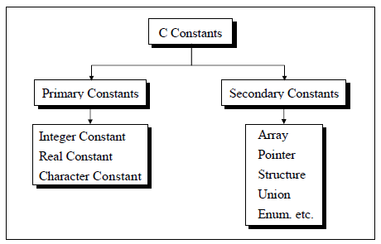
- Operators in C
C operators are one of the features in C which has symbols that can be used to perform mathematical, relational, bitwise, conditional, or logical manipulations.
Types of Operators in C
- Arithmetic Operator
- Increment/Decrement Operator
- Assignment Operator
- Logical Operator
- Bitwise Operator
- Misc Operator
1. Arithmetic Operator
Arithmetic Operators are the operators which are used to perform mathematical calculations like addition (+), subtraction (-), multiplication (*), division (/), and modulus (%). It performs all the operations on numerical values (constants and variables).
2.Increment/Decrement Operator
C programming has basically two operators which can increment ++ and decrement -- the value of a variable. It can change the value of an operand (constant or variable) by 1. Increment and Decrement Operators are very useful operators that are generally used to minimize the calculation. These two operators are unary operators, which means they can only operate on a single operand.
3. Assignment Operator
An assignment operator is mainly responsible for assigning a value to a variable in a program. Assignment operators are applied to assign the result of an expression to a variable.
4. Relational Operator
Relational operators are specifically used to compare two quantities or values in a program. It checks the relationship between two operands. If the given relation is true, it will return 1 and if the relation is false, then it will return 0. Relational operators are heavily used in decision-making and performing loop operations.
5. Logical Operator
In the C programming language, we have three logical operators when we need to test more than one condition to make decisions. These logical operators are:
&& (meaning logical AND)
|| (meaning logical OR)
! (meaning logical NOT)
An expression containing a logical operator in C language returns either 0 or 1 depending upon the condition whether the expression results in true or false. Logical operators are generally used for decision-making in C programming.

6. Bitwise Operator
Bitwise operators are the operators which work on bits and perform the bit-by-bit operation. Mathematical operations like addition, subtraction, multiplication, division, etc are converted to bit-level which makes processing faster and easier to implement during computation and compiling of the program.
7. Misc Operator
Besides all the other operators discussed above, the C programming language also offers a few other important operators including sizeof, comma, pointer(*), and conditional operator (?:).

& | It returns the address of a memory location of a variable. | &a; returns the actual address of the variable.  It can be any address in the memory like 4, 70,104.
* | Pointer to a variable. | *a; It points to the value of the variable.
? : | conditional operator (?: in combination) to construct conditional expressions. | If Condition is true ? then value X : otherwise value Y will be returned as output.

- Operator Precedence in C
Operator precedence is also one of the features in the C programming language which helps to determine the grouping of terms in an expression and decides how an expression is evaluated as per the provided expressions.
Some operators have higher precedence than others and some have lower precedence than others.
For example, in C Language, the multiplication operator has higher precedence than the addition operator.
For expression x = 7 + 4 * 2 , x is assigned 15 and not 22 because Multiplication operator * has higher precedence than the addition operator +. So, it first multiplies 4 with 2 and then adds 7 into the expression.
- Expressions
Expressions are the combination of variables, operands, and operators. The result would be stored in the variable once the expressions are processed based on the operator's precedence.
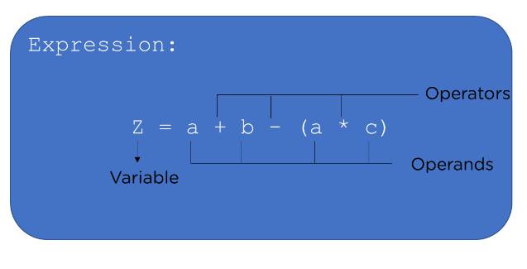
Types of Expressions in C
- Arithmetic expressions
- Relational expressions
- Logical expressions
- Conditional expressions

1. Arithmetic Expressions:
The arithmetic expression is evaluated in specific order considering the operator's precedence, and the result of an expression will be based on the type of variable.
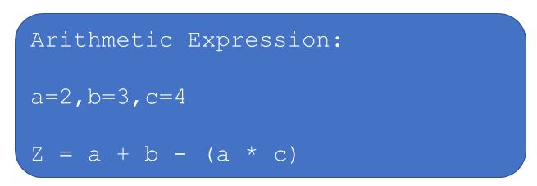
2.Relational Expressions:
Relational operators >, <, ==,!= etc are used to compare 2 operands. Relational expressions consisting of operands, variables, operators, and the result after evaluation would be either true or false.
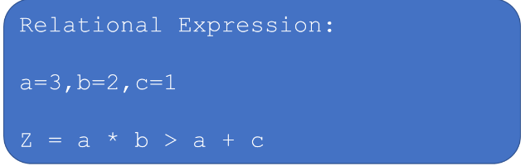
3.Logical Expressions:
Relational expressions and arithmetic expressions relate to the logical operators, and the result after an evaluation is stored in the variable, which is either true or false.
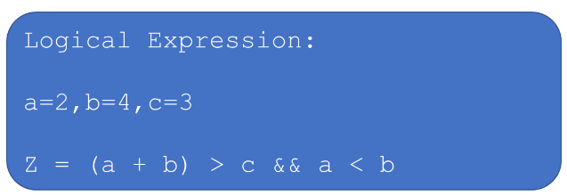
4. Conditional Expressions:
The general syntax of conditional expression is:
Exp1? Exp2: Exp3
From the given above expressions, the first expression (exp1) is conditional, and if the condition is satisfied, then expression2 will be executed; otherwise, expression3 will be performed.
